**PORTFOLIO PROJECT**

Submitted by

**GOKUL KANNAN A**

**Reg. No: 1P22MC014**

In partial fulfilment of the requirement for the award of the Degree of

**Master of Computer Applications**

**Bharathiar University**

**Coimbatore**.

Under the Internal Supervision of

**Mrs K Swathy**

**Faculty**

**School of Computer Studies-MCA**



**Master of Computer Applications,**

**Rathnavel Subramaniam College of Arts and Science (Autonomous),**

**Sulur, Coimbatore – 641 402**

**DECEMBER 2022**

**RATHNAVEL SUBRAMANIAM COLLEGE OF ARTS AND SCIENCE**

**(AUTONOMOUS)**

**AFFILIATED TO BHARATHIAR UNIVERSITY**

**NAAC Re-accredited & ISO 9000:2008 Certified**

**SULUR, COIMBATORE-641402.**



**December 2022**

**Register Number – 1P22MC014**

Certified bonafide original record of work done by **GOKUL KANNAN A**

**Internal Supervisor HOD**

Submitted for the project Evaluation and Viva voice held on**………………….**

**Internal Examiner External Examiner**

**PORTFOLIO PROJECT**

**Chapter-1:** 1

Video Introduction

* 1. YouTube video

**Chapter-2:** 2

Website Bio Score

2.1 About me

2.2 Contact Information

**Chapter-3:** 11

Pages & Navigations

3.1 Landing Page

3.2 Project Page

3.3 Navigation Bar

3.4 Skill Page

**Chapter-4:** 29

Style Score

4.1 Styles

4.2 Style links

4.3 Use of Grid layout

**Chapter-5:** 31

Website include the following Information

5.1 Project link to the GitHub

5.2 Project Description

**Chapter-6:** 32

Bootstrap

6.1 Uses of Bootstrap

**Chapter-7:** 33

Project README

7.1 Title description

7.2 How to run the project

7.3 Future improvement in the project

**Chapter-8:** 36

File structure

8.1 GitHub file structure

**PORTFOLIO PROJECT**

**Chapter 1:**

Video Introduction

1.1-

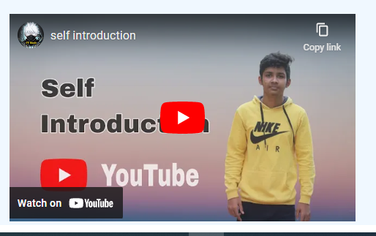

<!-- Self Introduction Video -->

<div>  <center>

    <iframe width="526" height="316" src="https://www.youtube.com/embed/o6k3DFSeNaE" title="YouTube video player" frameborder="0" allow="accelerometer; autoplay; clipboard-write; encrypted-media; gyroscope; picture-in-picture" allowfullscreen></iframe>

  </center></div>

</div>

**Chapter 2:**

Website Bio Score

2.1- About Page

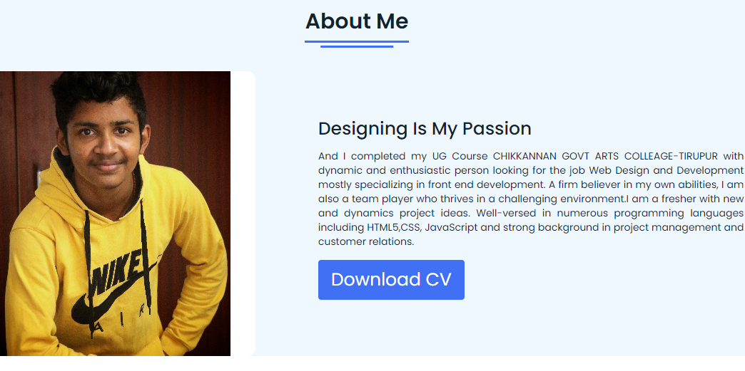

Description:

In this page, there is an Image of mine, about me and also an option called DOWNLOAD RESUME. So, that if any user want to see the resume they can directly download from here.

Index:

<!-- About Section Start -->

<section class="about" id="about">

  <div class="content">

    <div class="title"><span>About Me</span></div>

  <div class="about-details">

    <div class="left">

      <img src="images/IMG_20220419_155027_510.jpg" alt="img">

    </div>

    <div class="right">

     <div class="topic">Designing Is My Passion</div>

      <p> And I completed my UG Course CHIKKANNAN GOVT ARTS COLLEAGE-TIRUPUR with  dynamic and enthusiastic person looking for the job Web Design and Development mostly specializing in front end development. A firm believer in my own abilities, I am also a

        team player who thrives in a challenging environment.I am a fresher with new and dynamics project ideas. Well-versed in numerous programming languages including HTML5,CSS, JavaScript and strong background in project management and customer relations.</p>

      <div class="button">

        <a href="file:///D:/note%20pad/gokul/DOUBLE%20PAGE%20(2).pdf" download="cv/sample.pdf"> <button>Download CV</button></a>

      </div>

    </div>

  </div>

  </div>

</section>

<!-- Self Introduction Video -->

<div class="video">

<center>

    <video width="400" height="200" controls>

    <source src=" " type="video/mp4">

    </video>

 </center>

</div>

css:

/* About Section Styling */

/* Those Elements Where We Have Apply Same CSS,

 I'm Selecting Directly 'Section Tag' and 'Class'  */

section{

  padding-top: 40px;

    background: #F0F8FF;

}

section .content{

  width: 80%;

  margin: 40px auto;

  font-family: 'Poppins', sans-serif;

}

.about .about-details{

  display: flex;

  justify-content: space-between;

  align-items: center;

}

section .title{

  display: flex;

  justify-content: center;

  margin-bottom: 40px;

}

section .title span{

  color: #0E2431;

  font-size: 30px;

  font-weight: 600;

  position: relative;

  padding-bottom: 8px;

}

section .title span::before,

section .title span::after{

  content: '';

  position: absolute;

  height: 3px;

  width: 100%;

  background: #4070f4;

  left: 0;

  bottom: 0;

}

section .title span::after{

  bottom: -7px;

  width: 70%;

  left: 50%;

  transform: translateX(-50%);

}

.about .about-details .left{

  width: 45%;

}

.about .left img{

  height: 400px;

  width: 400px;

  object-fit: cover;

  border-radius: 12px;

}

.about-details .right{

  width: 55%;

}

section  .topic{

  color: #0E2431;

  font-size: 25px;

  font-weight: 500;

  margin-bottom: 10px;

}

.about-details .right p{

  text-align: justify;

  color: #0E2431;

}

section .button{

  margin: 16px 0;

}

section .button button{

  outline: none;

  padding: 8px 16px;

  border-radius: 4px;

  font-size: 25px;

  font-weight: 400;

  background: #4070f4;

  color: #fff;

  border: 2px solid transparent;

  cursor: pointer;

  transition: all 0.4s ease;

}

section .button button:hover{

  border-color: #4070f4;

  background-color: #fff;

  color: #4070f4;

}}

2.2-Contact Page

Figure 2.2.1

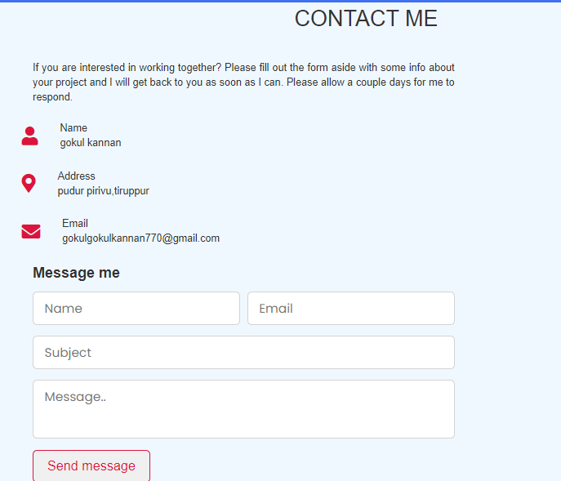

### Description:

The above displayed figure is a contact page in the website. If the user wants to contact me, they can fill the form with their valid details. Once the user filled and submitted the form the page will be displayed as figure 2.2.1. This will be possible only after filled the all fields in the form.

Index:

        <!-- contact section start -->

        <section class="contact" id="contact">

          <div class="max-width">

              <h2 class="title">CONTACT ME</h2>

              <div class="contact-content">

                  <div class="column left">

                      <p>If you are interested in working together? Please fill out the form aside with some info about your project and I will get back to you as soon as I can. Please allow a couple days for me to respond.</p>

                      <div class="icons">

                          <div class="row">

                              <i class="fas fa-user"></i>

                              <div class="info">

                                  <div class="head">Name</div>

                                  <div class="sub-title">gokul kannan</div>

                              </div>

                          </div>

                          <div class="row">

                              <i class="fas fa-map-marker-alt"></i>

                              <div class="info">

                                  <div class="head">Address</div>

                                  <div class="sub-title">pudur pirivu,tiruppur</div>

                              </div>

                          </div>

                          <div class="row">

                              <i class="fas fa-envelope"></i>

                              <div class="info">

                                  <div class="head">Email</div>

                                  <div class="sub-title">gokulgokulkannan770@gmail.com</div>

                              </div>

                          </div>

                      </div>

                  </div>

                  <div class="column right">

                      <div class="text">Message me</div>

                      <form action="#">

                          <div class="fields">

                              <div class="field name">

                                  <input type="text" placeholder="Name" required>

                              </div>

                              <div class="field email">

                                  <input type="email" placeholder="Email" required>

                              </div>

                          </div>

                          <div class="field">

                              <input type="text" placeholder="Subject" required>

                          </div>

                          <div class="field textarea">

                              <textarea cols="30" rows="10" placeholder="Message.." required></textarea>

                          </div>

                          <div class="button-area">

                              <button type="submit">Send message</button>

                          </div>

                      </form>

                  </div>

              </div>

          </div>

      </section>

<!-- contact section ends -->

Css:

/* contact section styling */

input,textarea

{

    caret-color: red;

}

.max-width{

  background: #F0F8FF;

}

.contact-content{

  margin-left:300px;

}

.contact .contact-content .column{

    width: calc(50% - 30px);

}

.contact .contact-content .text{

    font-size: 20px;

    font-weight: 600;

    margin-bottom: 10px;

}

.contact .contact-content .left p{

    text-align: justify;

}

.contact .contact-content .left .icons{

    margin: 10px 0;

}

.contact .contact-content .row{

    display: flex;

    height: 65px;

    align-items: center;

}

.contact .contact-content .row .info{

    margin-left: 30px;

}

.contact .contact-content .row i{

    font-size: 25px;

    color: crimson;

}

.contact .contact-content .info .head{

    font-weight: 500;

}

.contact .contact-content .info .sub-title{

    color: #333;

}

.contact .right form .fields{

    display: flex;

}

.contact .right form .field,

.contact .right form .fields .field{

    height: 45px;

    width: 100%;

    margin-bottom: 15px;

}

.contact .right form .textarea{

    height: 80px;

    width: 100%;

}

.contact .right form .name{

    margin-right: 10px;

}

.contact .right form .field input,

.contact .right form .textarea textarea{

    height: 100%;

    width: 100%;

    border: 1px solid lightgrey;

    border-radius: 6px;

    outline: none;

    padding: 0 15px;

    font-size: 17px;

    font-family: 'Poppins', sans-serif;

    transition: all 0.3s ease;

}

.contact .right form .field input:focus,

.contact .right form .textarea textarea:focus{

    border-color: #b3b3b3;

}

.contact .right form .textarea textarea{

  padding-top: 10px;

  resize: none;

}

.contact .right form .button-area{

  display: flex;

  align-items: center;

}

.right form .button-area button{

  color: crimson;

  display: block;

  width: 160px!important;

  height: 45px;

  outline: none;

  font-size: 18px;

  font-weight: 500;

  border-radius: 6px;

  cursor: pointer;

  flex-wrap: nowrap;

  border: 2px solid crimson;

  transition: all 0.3s ease-in-out;

}

.right form .button-area button:hover{

  color: white;

  background: crimson;

}

**Chapter 3:**

**Pages & Navigation**

3.1-Landing Page

3.3.1



Index:

  <nav>

    <div class="navbar">

      <div class="logo"><a href="#">gokul</a></div>

      <ul class="menu">

          <li><a href="#home">Home</a></li>

          <li><a href="#about">About</a></li>

          <li><a href="#skills">Skills</a></li>

          <li><a href="#services">projects</a></li>

          <li><a href="#contact">Contact</a></li>

          <div class="cancel-btn">

            <i class="fas fa-times"></i>

          </div>

      </ul>

      <div class="media-icons">

        <a href="#"><i class="fab fa-facebook-f"></i></a>

        <a href="#"><i class="fab fa-twitter"></i></a>

        <a href="#"><i class="fab fa-instagram"></i></a>

      </div>

    </div>

    <div class="menu-btn">

      <i class="fas fa-bars"></i>

    </div>

  </nav>

<!-- Home Section Start -->

 <section class="home" id="home">

   <div class="home-content">

     <div class="text">

       <div class="text-one">Hello,</div>

       <div class="text-two">I'm gokul kannan</div>

       <div class="text-three">Frontend Developer</div>

     </div>

     <div class="button">

<a href="../DOUBLE PAGE (2).pdf"> <button>Resume</button></a>

     </div>

   </div>

 </section><!-- home section ends -->

Css:

/* navbar styling */

nav{

  position: fixed;

  width: 100%;

  padding: 20px 0;

  z-index: 998;

  transition: all 0.3s ease;

  font-family: 'Ubuntu', sans-serif;

}

nav.sticky{

  background: #4070f4;

  padding: 13px 0;

}

nav .navbar{

  width: 90%;

  display: flex;

  justify-content: space-between;

  align-items: center;

  margin: auto;

}

nav .navbar .logo a{

  font-weight: 500;

  font-size: 35px;

  color: red;

}

nav.sticky .navbar .logo a{

  color: #fff;

}

nav .navbar .menu{

  display: flex;

  position: relative;

}

nav .navbar .menu li{

  list-style: none;

  margin: 0 8px;

}

.navbar .menu a{

  font-size: 23px;

  font-weight: 500;

  color: #0E2431;

  padding: 6px 0;

  transition: all 0.4s ease;

}

.navbar .menu a:hover{

  color: #4070f4;

  font-size: 28px;

}

nav.sticky .menu a{

  color: #FFF;

}

nav.sticky .menu a:hover{

  color: #0E2431;

}

.navbar .media-icons a{

  color: #4070f4;

  font-size: 27px;

  margin: 0 6px;

}

.navbar .media-icons a:hover{

  color: black;

  font-size: 34px;

}

nav.sticky .media-icons a{

  color: #FFF;

}

/* Side Navigation Menu Button CSS */

nav .menu-btn,

.navbar .menu .cancel-btn{

  position: absolute;

  color:red;

  right: 30px;

  top: 20px;

  font-size: 20px;

  cursor: pointer;

  transition: all 0.3s ease;

  display: none;

}

nav .menu-btn{

  color: #4070f4;

}

nav.sticky .menu-btn{

  color: #FFF;

}

.navbar .menu .menu-btn{

  color: #fff;

}

/* home section styling */

.home{

  height: 100vh;

  width: 100%;

  background: url("../Images/desktop.jpg") no-repeat;

  background-size: cover;

  background-position: center;

  background-attachment: fixed;

  font-family: 'Ubuntu', sans-serif;

}

.home .home-content{

  width: 90%;

  height: 100%;

  margin: auto;

  display: flex;

  flex-direction: column;

  justify-content: center;

}

.home .text-one{

  font-size: 25px;

  color: #0E2431;

}

.home .text-two{

  color: #0E2431;

  font-size: 75px;

  font-weight: 600;

  margin-left: -3px;

}

.home .text-three{

  font-size: 40px;

  margin: 5px 0;

  color: red;

}

.home .text-four{

  font-size: 23px;

  margin: 5px 0;

  color: #0E2431;

}

.home .button{

  margin: 14px 0;

}

.home .button button{

  outline: none;

  padding: 8px 16px;

  border-radius: 6px;

  font-size: 25px;

  font-weight: 400;

  background: red;

  color: #fff;

  cursor: pointer;

  border: 2px solid transparent;

  transition: all 0.4s ease;

}

.home .button button:hover{

  border-color: red;

  background-color:blue;

  color: white;

}

}

3.2-Project Page

Figure 3.2.1

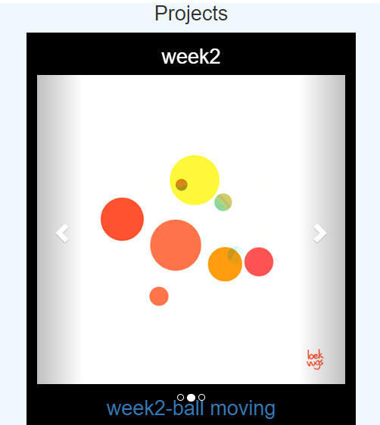

Figure 3.2.2

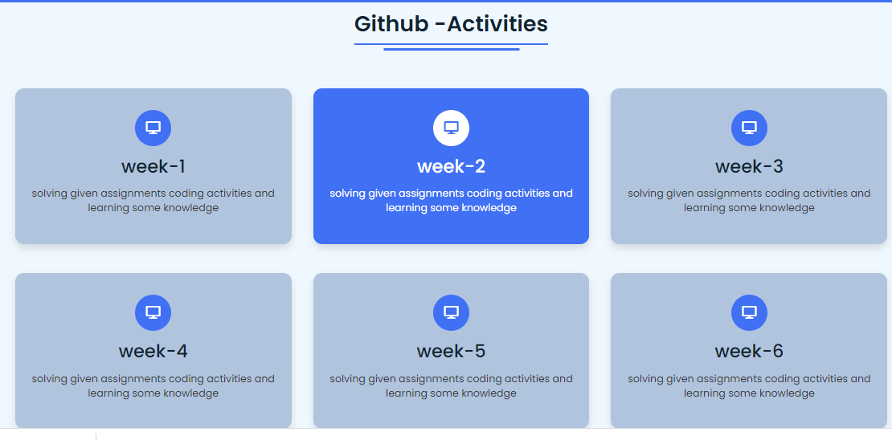

### Description:

The above figures 3.2.1, 3.2.2 are the screenshot of project and activities page in a desktop view.

Index:

<!--===== Project =====-->

      <div class="proj">

        <center><h2 class="title"><span>Projects</span></h2> </center>

      <div class="container" style="width:32%;">

        <div id="myCarousel" class="carousel slide" data-ride="carousel">

          <!-- Indicators -->

          <ol class="carousel-indicators">

            <li data-target="#myCarousel" data-slide-to="0" class="active"></li>

            <li data-target="#myCarousel" data-slide-to="1"></li>

            <li data-target="#myCarousel" data-slide-to="2"></li>

          </ol>

          <!-- Wrapper for slides -->

          <div class="carousel-inner" >

            <div class="item active">

              <center> <h2 class="weeek">week2</h2></center>

              <img src="Images/threeball.gif" alt="New york" style="width:100%;">

            <a href="https://github.com/RathnavelSubramaniam/week-2-javascript-GOKULKANNAN1604.git"> <center> <h2>week2-ball creating</h2></center></a>

            </div>

            <div class="item">

              <center> <h2 class="weeek">week2</h2></center>

              <img src="Images/9IBr.gif" alt="Chicago" style="width:100%;">

             <a href="https://github.com/RathnavelSubramaniam/week-2-javascript-GOKULKANNAN1604.git"><center> <h2>week2-ball moving</h2></center></a>

            </div>

            <div class="item">

              <center> <h2 class="weeek">week4</h2></center>

              <img src="Images/pacman.gif" alt="Los Angeles" style="width:100%;">

              <a href="https://github.com/RathnavelSubramaniam/week-4-introduction-to-javascript-GOKULKANNAN1604.git"><center> <h2>week4-pacman</h2></center></a>

            </div>

          </div>

          <!-- Left and right controls -->

          <a class="left carousel-control" href="#myCarousel" data-slide="prev">

            <span class="glyphicon glyphicon-chevron-left"></span>

            <span class="sr-only">Previous</span>

          </a>

          <a class="right carousel-control" href="#myCarousel" data-slide="next">

            <span class="glyphicon glyphicon-chevron-right"></span>

            <span class="sr-only">Next</span>

          </a>

        </div>

      </div>

    </div>

<!-- slide section end -->

 <!-- My Activities Section Start -->

 <section class="services" id="services">

  <div class="content">

    <div class="title"><span>Github -Activities</span></div>

    <div class="boxes">

      <div class="box">

        <div class="icon">

          <i class="fas fa-desktop"></i>

      </div>

     <a href="https://github.com/RathnavelSubramaniam/week-1-javascript-GOKULKANNAN1604.git"><div class="topic">week-1</div></a>

      <p>solving given assignments coding activities and learning some knowledge</p>

    </div>

      <div class="box">

        <div class="icon">

          <i class="fas fa-desktop"></i>

      </div>

      <a href="https://github.com/RathnavelSubramaniam/week-2-javascript-GOKULKANNAN1604.git"><div class="topic">week-2</div></a>

      <p>solving given assignments coding activities and learning some knowledge</p>

    </div>

      <div class="box">

        <div class="icon">

          <i class="fas fa-desktop"></i>

      </div>

     <a href="https://github.com/RathnavelSubramaniam/week-3-javascript-GOKULKANNAN1604.git"> <div class="topic">week-3</div></a>

      <p>solving given assignments coding activities and learning some knowledge</p>

    </div>

      <div class="box">

        <div class="icon">

          <i class="fas fa-desktop"></i>

      </div>

      <a href="https://github.com/RathnavelSubramaniam/week-4-introduction-to-javascript-GOKULKANNAN1604.git"> <div class="topic">week-4</div></a>

      <p>solving given assignments coding activities and learning some knowledge</p>

    </div>

      <div class="box">

        <div class="icon">

          <i class="fas fa-desktop"></i>

      </div>

      <a href="https://github.com/RathnavelSubramaniam/week-5-functions---array-manipulation-and-scope-GOKULKANNAN1604.git"><div class="topic">week-5</div></a>

      <p>solving given assignments coding activities and learning some knowledge</p>

    </div>

      <div class="box">

        <div class="icon">

          <i class="fas fa-desktop"></i>

      </div>

     <a href="https://github.com/RathnavelSubramaniam/week-6-call-back-functions-GOKULKANNAN1604.git"><div class="topic">week-6</div></a>

      <p>solving given assignments coding activities and learning some knowledge</p>

    </div>

      <div class="box">

        <div class="icon">

          <i class="fas fa-desktop"></i>

      </div>

     <a href="https://github.com/RathnavelSubramaniam/week-7-git-hub-testing-dom-GOKULKANNAN1604.git"><div class="topic">week-7</div></a>

      <p>solving given assignments coding activities and learning some knowledge</p>

    </div>

      <div class="box">

        <div class="icon">

          <i class="fas fa-desktop"></i>

      </div>

     <a href="https://github.com/RathnavelSubramaniam/week-8-styles-bootstarp-GOKULKANNAN1604.git"> <div class="topic">week-8</div></a>

      <p>solving given assignments coding activities and learning some knowledge</p>

    </div>

      <div class="box">

        <div class="icon">

          <i class="fas fa-desktop"></i>

      </div>

      <div class="topic">week-9</div>

      <p>solving given assignments coding activities and learning some knowledge</p>

    </div>

     <div class="box">

        <div class="icon">

          <i class="fas fa-desktop"></i>

      </div>

      <div class="topic">week-10</div>

      <p>solving given assignments coding activities and learning some knowledge</p>

    </div>

  </div>

  </div>

</section>

<!-- Activities section ends -->

Css:

     <!-- bootstrap Link -->

     <link rel="stylesheet" href="https://maxcdn.bootstrapcdn.com/bootstrap/3.4.1/css/bootstrap.min.css">

     <script src="https://ajax.googleapis.com/ajax/libs/jquery/3.6.1/jquery.min.js"></script>

     <script src="https://maxcdn.bootstrapcdn.com/bootstrap/3.4.1/js/bootstrap.min.js"></script>

/* My activities CSS */

.services .boxes{

  display: flex;

  flex-wrap: wrap;

  justify-content: space-between;

}

.services .boxes .box{

  margin: 20px 0;

  width: calc(100% / 3 - 20px);

  text-align: center;

  border-radius: 12px;

  padding: 30px 10px;

  box-shadow: 0 5px 10px rgba(0, 0, 0, 0.12);

  cursor: default;

  transition: all 0.4s ease;

  background-color:lightsteelblue;

}

.services .boxes .box:hover{

  background: #4070f4;

  color: #fff;

}

.services .boxes .box .icon{

  height: 50px;

  width: 50px;

  background: #4070f4;

  border-radius: 50%;

  text-align: center;

  line-height: 50px;

  font-size: 18px;

  color: #fff;

  margin: 0 auto 10px auto;

  transition: all 0.4s ease;

}

.boxes .box:hover .icon{

  background-color: #fff;

  color: #4070f4;

}

.services .boxes .box:hover .topic,

.services .boxes .box:hover p{

  color: #0E2431;

  transition: all 0.4s ease;

}

.services .boxes .box:hover .topic,

.services .boxes .box:hover p{

  color: #fff;

}

3.3-Navigation Bar

Figure 3.3.1

Desktop View:



Index:

<!-- navgaition menu -->

  <nav>

    <div class="navbar">

      <div class="logo"><a href="#">gokul</a></div>

      <ul class="menu">

          <li><a href="#home">Home</a></li>

          <li><a href="#about">About</a></li>

          <li><a href="#skills">Skills</a></li>

          <li><a href="#services">projects</a></li>

          <li><a href="#contact">Contact</a></li>

          <div class="cancel-btn">

            <i class="fas fa-times"></i>

          </div>

      </ul>

      <div class="media-icons">

        <a href="#"><i class="fab fa-facebook-f"></i></a>

        <a href="#"><i class="fab fa-twitter"></i></a>

        <a href="#"><i class="fab fa-instagram"></i></a>

      </div>

    </div>

    <div class="menu-btn">

      <i class="fas fa-bars"></i>

    </div>

  </nav>

 </section>

Css:

nav{

  position: fixed;

  width: 100%;

  padding: 20px 0;

  z-index: 998;

  transition: all 0.3s ease;

  font-family: 'Ubuntu', sans-serif;

}

nav.sticky{

  background: #4070f4;

  padding: 13px 0;

}

nav .navbar{

  width: 90%;

  display: flex;

  justify-content: space-between;

  align-items: center;

  margin: auto;

}

nav .navbar .logo a{

  font-weight: 500;

  font-size: 35px;

  color: red;

}

nav.sticky .navbar .logo a{

  color: #fff;

}

nav .navbar .menu{

  display: flex;

  position: relative;

}

nav .navbar .menu li{

  list-style: none;

  margin: 0 8px;

}

.navbar .menu a{

  font-size: 23px;

  font-weight: 500;

  color: #0E2431;

  padding: 6px 0;

  transition: all 0.4s ease;

}

.navbar .menu a:hover{

  color: #4070f4;

  font-size: 28px;

}

nav.sticky .menu a{

  color: #FFF;

}

nav.sticky .menu a:hover{

  color: #0E2431;

}

.navbar .media-icons a{

  color: #4070f4;

  font-size: 27px;

  margin: 0 6px;

}

.navbar .media-icons a:hover{

  color: black;

  font-size: 34px;

}

nav.sticky .media-icons a{

  color: #FFF;

}

/* Side Navigation Menu Button CSS */

nav .menu-btn,

.navbar .menu .cancel-btn{

  position: absolute;

  color:red;

  right: 30px;

  top: 20px;

  font-size: 20px;

  cursor: pointer;

  transition: all 0.3s ease;

  display: none;

}

nav .menu-btn{

  color: #4070f4;

}

nav.sticky .menu-btn{

  color: #FFF;

}

.navbar .menu .menu-btn{

  color: #fff;

}

Figure 3.3.2

Mobile View:



# Description:

The above figures Shows the Navigation bars in Desktop view and Mobile modes

Css:

@media (max-width: 750px) {

  nav .navbar{

    width: 90%;

  }

  nav .navbar .menu{

    position: fixed;

    left: -100%;

    top: 0;

    background: #0E2431;

    height: 100vh;

    max-width: 400px;

    width: 100%;

    padding-top: 60px;

    flex-direction: column;

    align-items: center;

    transition: all 0.5s ease;

  }

  .navbar.active .menu{

    left: 0;

  }

  nav .navbar .menu a{

    font-size: 23px;

    display: block;

    color: #fff;

    margin: 10px 0;

  }

  nav.sticky .menu a:hover{

    color: #4070f4;

  }

  nav .navbar .media-icons{

    display: none;

  }

  nav .menu-btn,

  .navbar .menu .cancel-btn{

    display: block;

  }

3.3 Skill View:

Figure 3.3.3

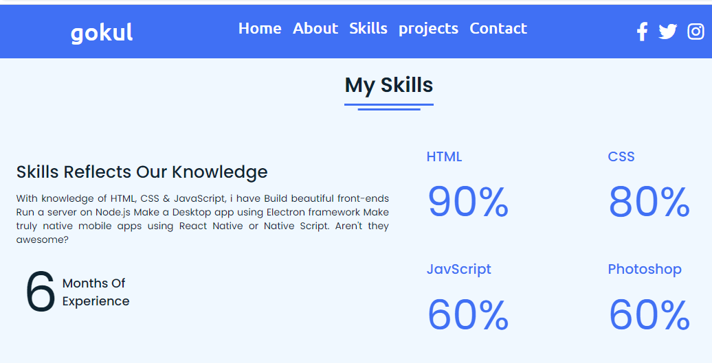

# Description:

The above figures are skill page, which contain a subdivision named PERSONAL SKILLS.

Index:

<!-- My Skill Section Start -->

<!-- Section Tag and Other Div will same where we need to put same CSS -->

<section class="skills" id="skills">

 <div class="content">

   <div class="title"><span>My Skills</span></div>

   <div class="skills-details">

     <div class="text">

       <div class="topic">Skills Reflects Our Knowledge</div>

       <p>With knowledge of HTML, CSS & JavaScript, i have

        Build beautiful front-ends

        Run a server on Node.js

        Make a Desktop app using Electron framework

        Make truly native mobile apps using React Native or Native Script.

        Aren't they awesome?</p>

       <div class="experience">

         <div class="num">6</div>

         <div class="exp">Months Of <br> Experience</div>

       </div>

     </div>

     <div class="boxes">

       <div class="box">

         <div class="topic">HTML</div>

         <div class="per">90%</div>

       </div>

       <div class="box">

         <div class="topic">CSS</div>

         <div class="per">80%</div>

       </div>

       <div class="box">

         <div class="topic">JavScript</div>

         <div class="per">60%</div>

       </div>

       <div class="box">

         <div class="topic">Photoshop</div>

         <div class="per">60%</div>

       </div>

     </div>

   </div>

 </div>

</section>

<!-- Skills end -->

Css:

/* My Skills CSS */

 .skills{

   background: #F0F8FF;

 }

 .skills .content{

   padding: 40px 0;

 }

 .skills .skills-details{

   display: flex;

   justify-content: space-between;

   align-items: center;

 }

 .skills-details .text{

   width: 50%;

 }

 .skills-details p{

   color: #0E2431;

   text-align: justify;

 }

.skills .skills-details .experience{

  display: flex;

  align-items: center;

  margin: 0 10px;

}

.skills-details .experience .num{

  color: #0E2431;

  font-size: 80px;

}

.skills-details .experience .exp{

  color: #0E2431;

  margin-left: 20px;

  font-size: 18px;

  font-weight: 500;

  margin: 0 6px;

}

.skills-details .boxes{

  width: 45%;

  display: flex;

  flex-wrap: wrap;

  justify-content: space-between;

}

.skills-details .box{

  width: calc(100% / 2 - 20px);

  margin: 20px 0;

}

.skills-details .boxes .topic{

  font-size: 20px;

  color: #4070f4;

}

.skills-details .boxes .per{

  font-size: 60px;

  color: #4070f4;

}

# 

# 

# Chapter-4:

### Styles Score

* 1. Font links

@import @import url('https://fonts.googleapis.com/css2?family=Poppins:wght@400;500;600;700&family=Ubuntu:wght@400;500;700&display=swap');

* 1. Style links

<!-- bootstrap Link -->

 <link rel="stylesheet" href="https://maxcdn.bootstrapcdn.com/bootstrap/3.4.1/css/bootstrap.min.css">

     <script src="https://ajax.googleapis.com/ajax/libs/jquery/3.6.1/jquery.min.js"></script>

     <script src="https://maxcdn.bootstrapcdn.com/bootstrap/3.4.1/js/bootstrap.min.js"></script>

# 

# 

# Chapter-5:

### Website include the following Information

* 1. project links to *Github:*

### * Project-1

**Title: *SIMULATION BALL MOVEMENT***

**Link:** [**https://github.com/GOKULKANNAN1604/Simulating-Moving-Ball**](https://github.com/GOKULKANNAN1604/Simulating-Moving-Ball)

**Project Description:**

This project has a simple red color ball, Which will move from Right to Left and Left to Right, like Running from between the x and y axis. It will repeat this process whenever we load the page. The ball is created by HTML, CSS. And making the ball to do some event by JAVASCRIPT.

### * Project-2

**Title: *GRAPHIC ANIMATION OF THE RANDOM WALK EXERCISE***

**Link:** [**https://github.com/GOKULKANNAN1604/Graphics-Animation-Of-The-Random-Walk-assignment.git**](https://github.com/GOKULKANNAN1604/Graphics-Animation-Of-The-Random-Walk-assignment.git)

* + - **Project Description:**

This was a graphic animation of the random ball using plain JavaScript. Drawing in HTML Canvas, also plain CSS is used. The balls will bounce randomly within the box

### *Project-3

**Title: *PAC-MAN MOVEMENT***

**Link:** [**https://github.com/GOKULKANNAN1604/Pacman.git**](%20https://github.com/GOKULKANNAN1604/Pacman.git)

**Project Description:**

In Simulation scheduler a Pac-man in made to move is fixed direction and with a fixed velocity. It will move from the one place of the browser to the end of the screen.

### * Project-4

**Title: *WALK BOSTON DATA CODING EXERCISE***

**Link:** [**https://github.com/GOKULKANNAN1604/Boston-City-Data.git**](%20https://github.com/GOKULKANNAN1604/Boston-City-Data.git)

**Project Description:**

The walk Boston shows the top five earning employees and the details of the employees by JAVASCRIPT. So through this we can identify and filter the top values from the n number of data

### Project-5

**Title: *FIND THE MOST COMMON WORD***

**Link:** [**https://github.com/GOKULKANNAN1604/Word-Count.git**](https://github.com/GOKULKANNAN1604/Word-Count.git)

* + - **Project Description:**

In this exercise, we can count the words that how many time it take place in the paragraph. And also it will display the top 3 repeated words.

# Chapter-6:

### Bootstrap

6.1 Use bootstrap

Figure- 6.1.1

<!-- bootstrap Link -->

     <link rel="stylesheet" href="https://maxcdn.bootstrapcdn.com/bootstrap/3.4.1/css/bootstrap.min.css">

     <script src="https://ajax.googleapis.com/ajax/libs/jquery/3.6.1/jquery.min.js"></script>

     <script src="https://maxcdn.bootstrapcdn.com/bootstrap/3.4.1/js/bootstrap.min.js"></script>

### Description:

I have used bootstrap in this website. Which was a ready- made CSS file, so we can use it to reduce our time and also it carries a (N) number of designs. So, I had linked them to the code in HTML.

# Chapter-7:

### Project README (Description, steps to run, future improvement)

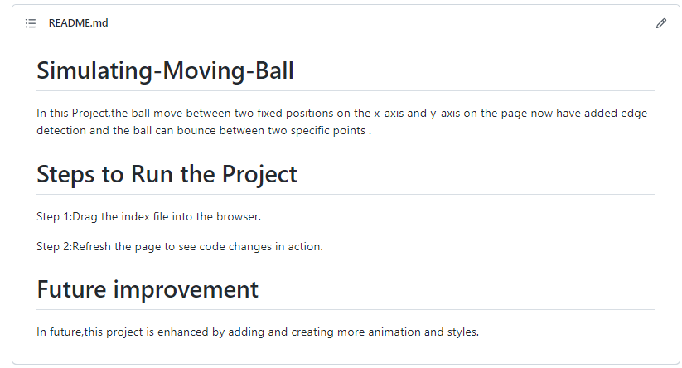* **Project-1- Simulation ball movement**

### * Project-2- Random walk movemen

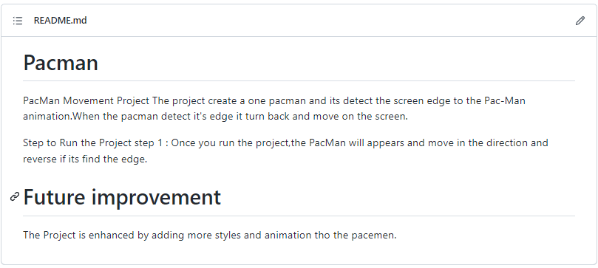 * **Project-3- Simulation scheduler**

### * Project-4- Walk Boston

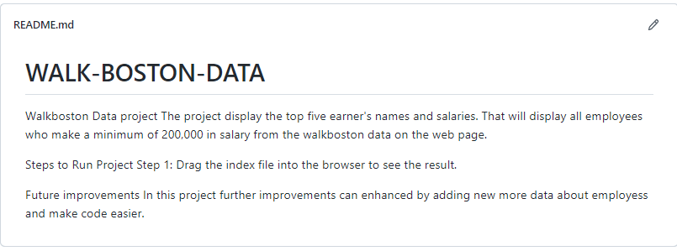

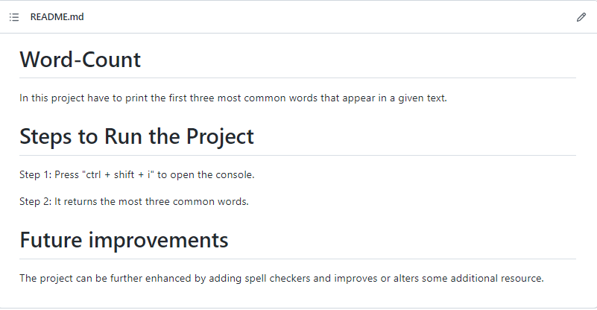* **Project-5- Word count**

# Chapter-8:

### File structure

**8.1 GitHub file structure**

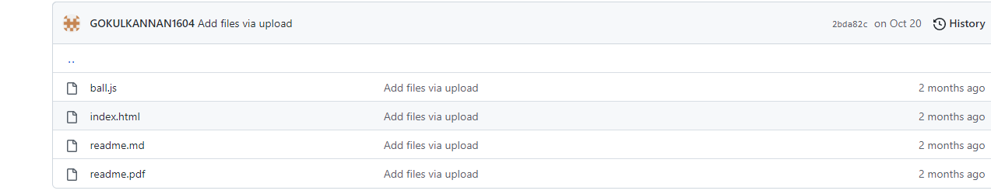Task- 1 file structure:

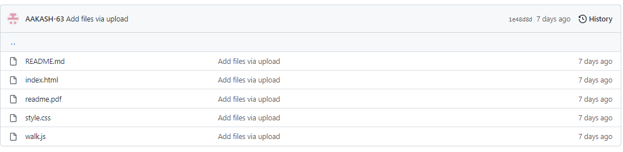Task- 2 file structure:

Task- 3 file structure:

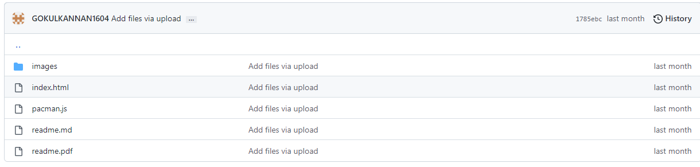

Task- 4 file structure:

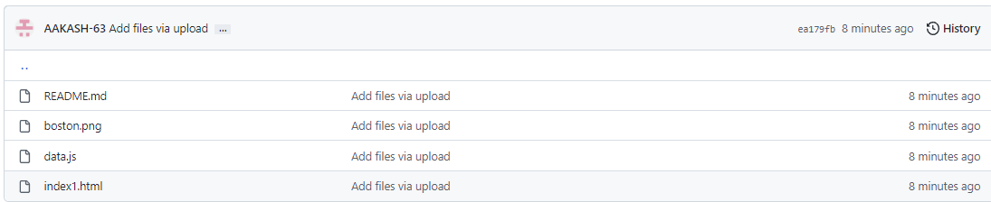

Task- 5 file structure:

